# Optional: Upload the customer dataset to BigQuery

In the next video, the instructor uses a specific dataset. Follow the instructions in this reading to upload the dataset in your BigQuery console so you can follow along.

You must have a BigQuery account to follow along. If you have hopped around courses, [Using BigQuery](https://www.coursera.org/learn/data-preparation/supplement/DYOQK/using-bigquery) in the Prepare Data for Exploration course covers how to set up a BigQuery account.

## Prepare for the next video

* First, download the CSV file directly from the attachment below.

[Customer Table - Sheet1.csv](https://d3c33hcgiwev3.cloudfront.net/F0iSyYcLT9iIksmHCw_Y-Q_191f150a80d74fda96f9df2aa2e3b533_Customer-Table---Sheet1.csv?Expires=1623110400&Signature=HvsQv2HJvLSzHOzv3KKzHf9Uy0grFe~PZXsPI0aB78fIGIftZna6L0PXyNmtDAvAl7hW9tXo~WPvBOEWGmvol3ZrfFT2VZehhkeJJ7wOla9oOpdZYLTLg247GO1rjDM4-O2XLh~83osipduqSPg4FA2DgwqjffYlvurfDdkBGVg_&Key-Pair-Id=APKAJLTNE6QMUY6HBC5A)

* Next, complete the following steps in your BigQuery console to upload the Customer Table dataset.

Step 1: Open your BigQuery console and click on the project you want to upload the data to.

Step 2: In the Explorer on the left, click the Actions icon (three vertical dots) next to your project name and select Create dataset.

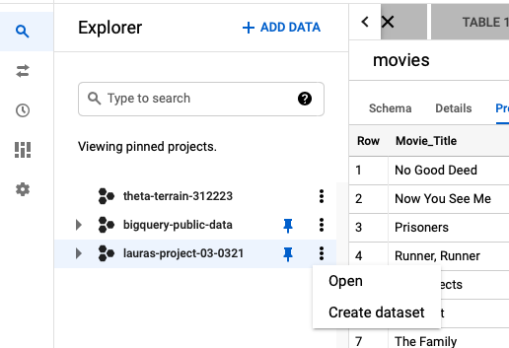

Step 3: In the upcoming video, the name "customer_data" will be used for the dataset. If you plan to follow along with the video, enter customer_data for the Dataset ID.

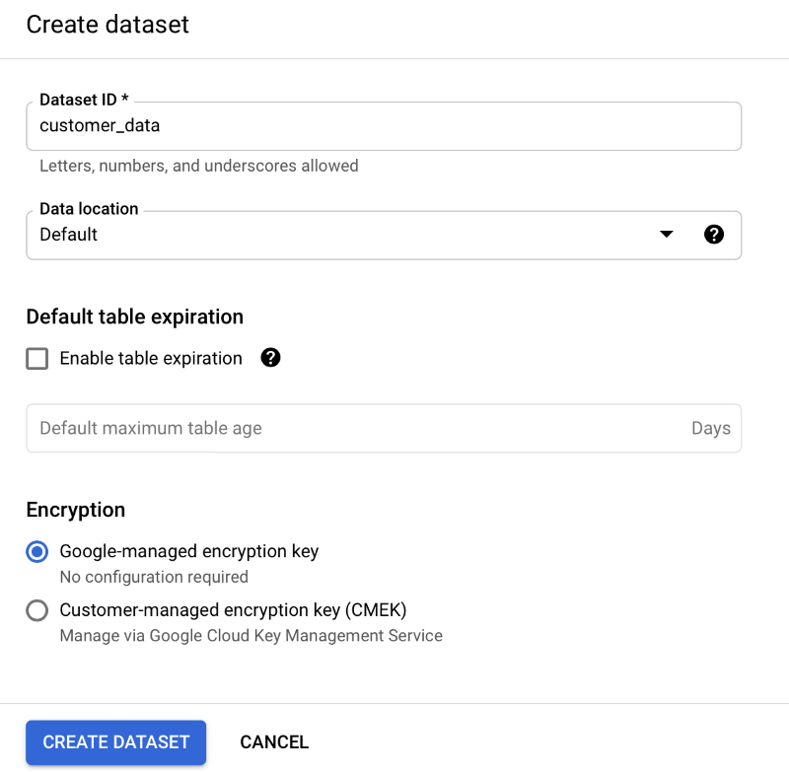

Step 4: Click CREATE DATASET (blue button) to add the dataset to your project.

Step 5: In the Explorer panel on the left, click to expand your project, and then click the customer_data dataset you just created.

Step 6: Click the Actions icon (three vertical dots) next to customer_data and select Open.

Step 7: Click the blue + icon at the top right to open the Create table window.

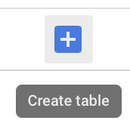

Step 8: Under Source, for the Create table from selection, choose where the data will be coming from.

* Select Upload.
* Click Browse to select the Customer Table CSV file you downloaded.
* Choose CSV from the file format drop-down.

Step 9: For Table name, enter customer_address if you plan to follow along with the video.

Step 10: For Schema, click the Auto detect check box.

Step 11: Click Create table (blue button). You will now see the customer_address table under your customer_data dataset in your project.

Step 12: Click customer_address and then select the Preview tab. Confirm that you see the data shown below.

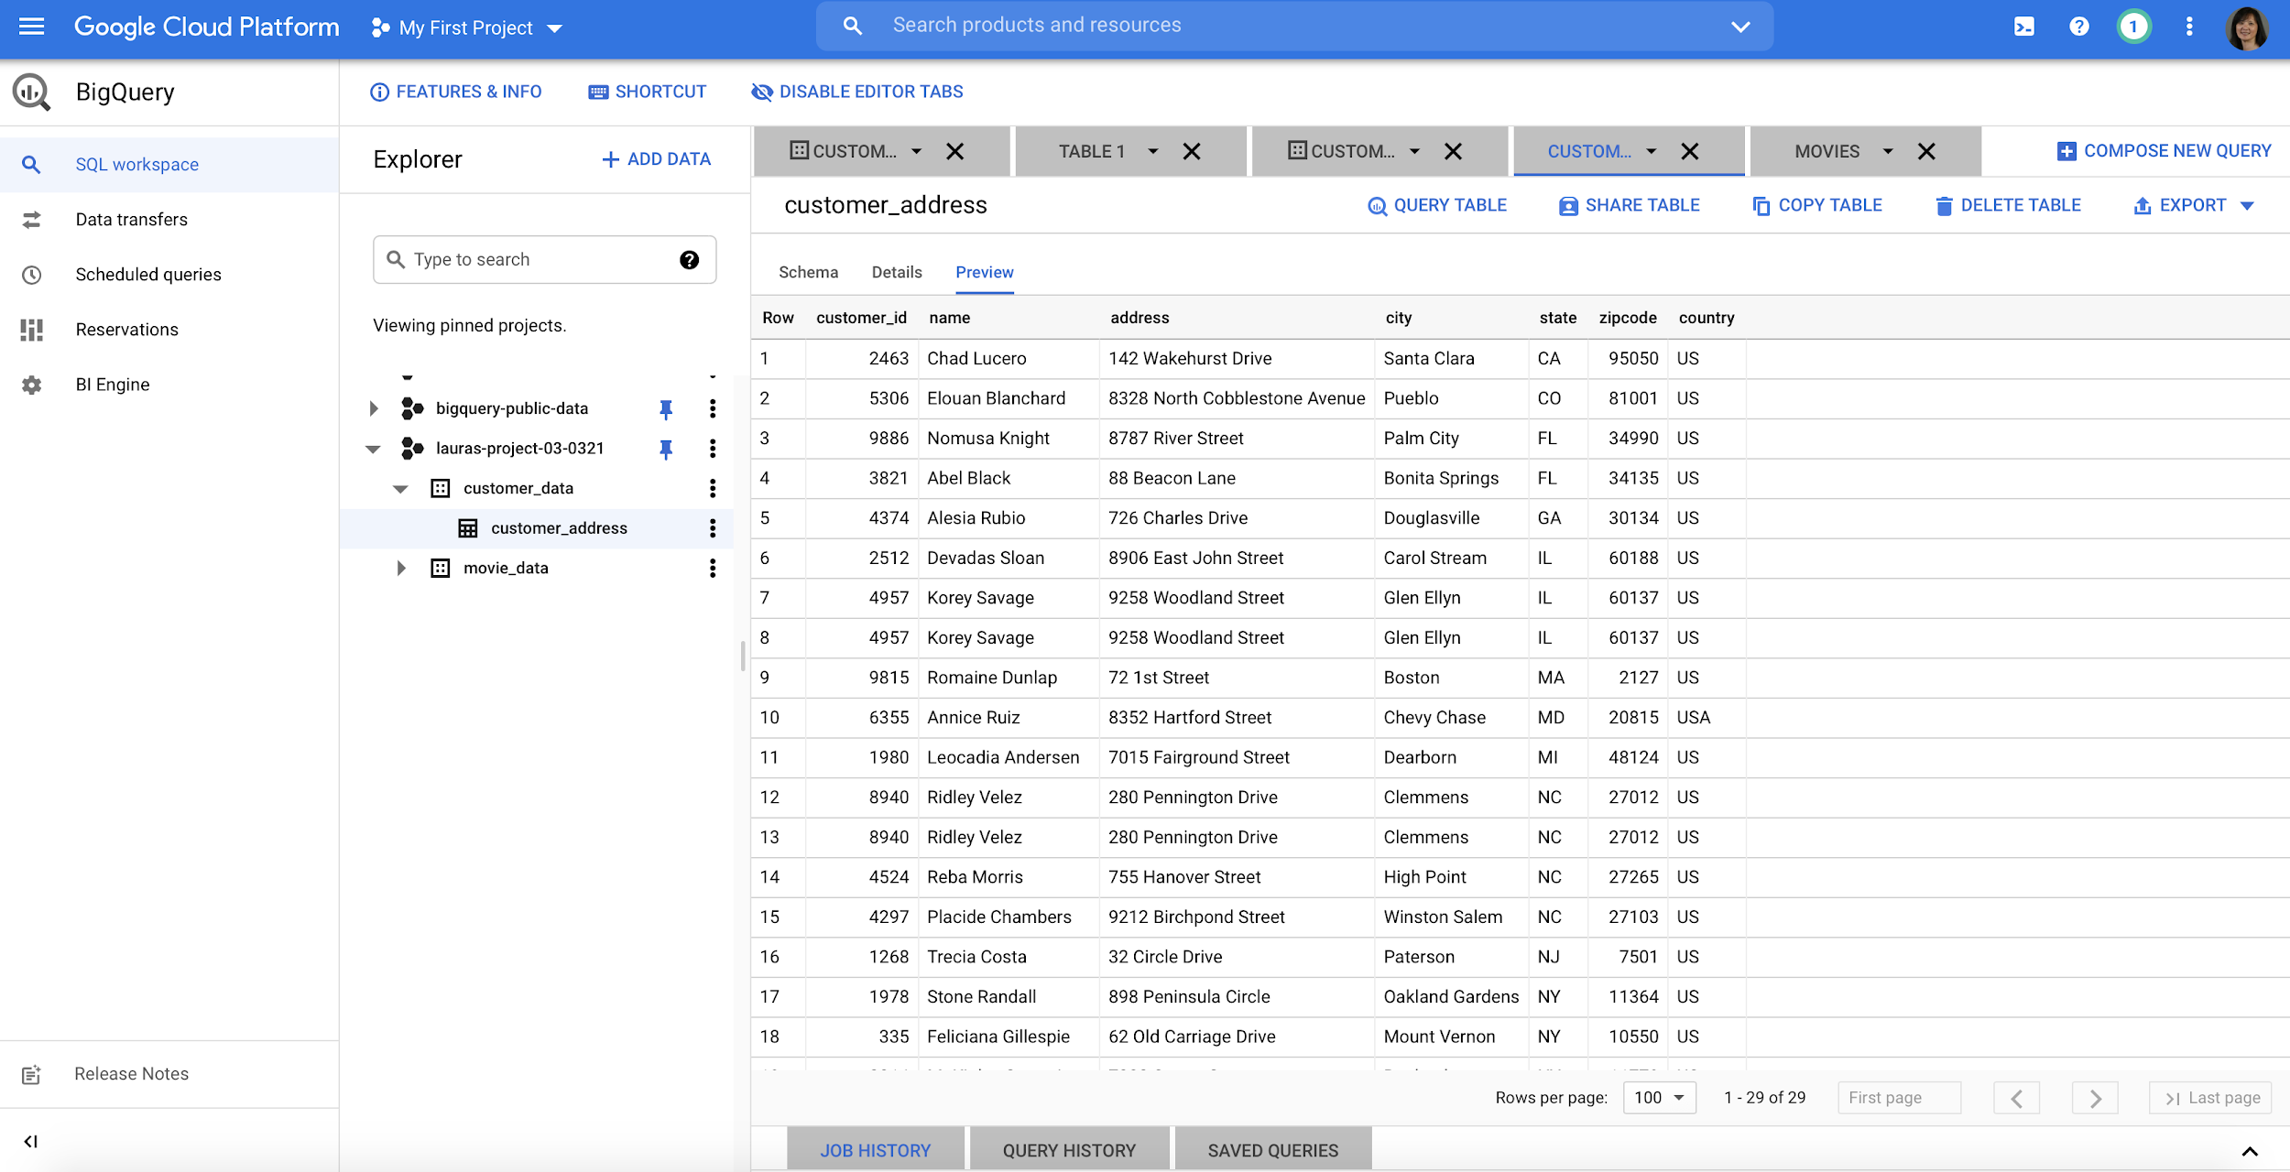

And now you have everything you need to follow along with the next video. This is also a great table to use to practice querying data on your own. Plus, you can use these steps to upload any other data you want to work with.